Q- Create a new database called ExamDB using the CLI.
Answer: -
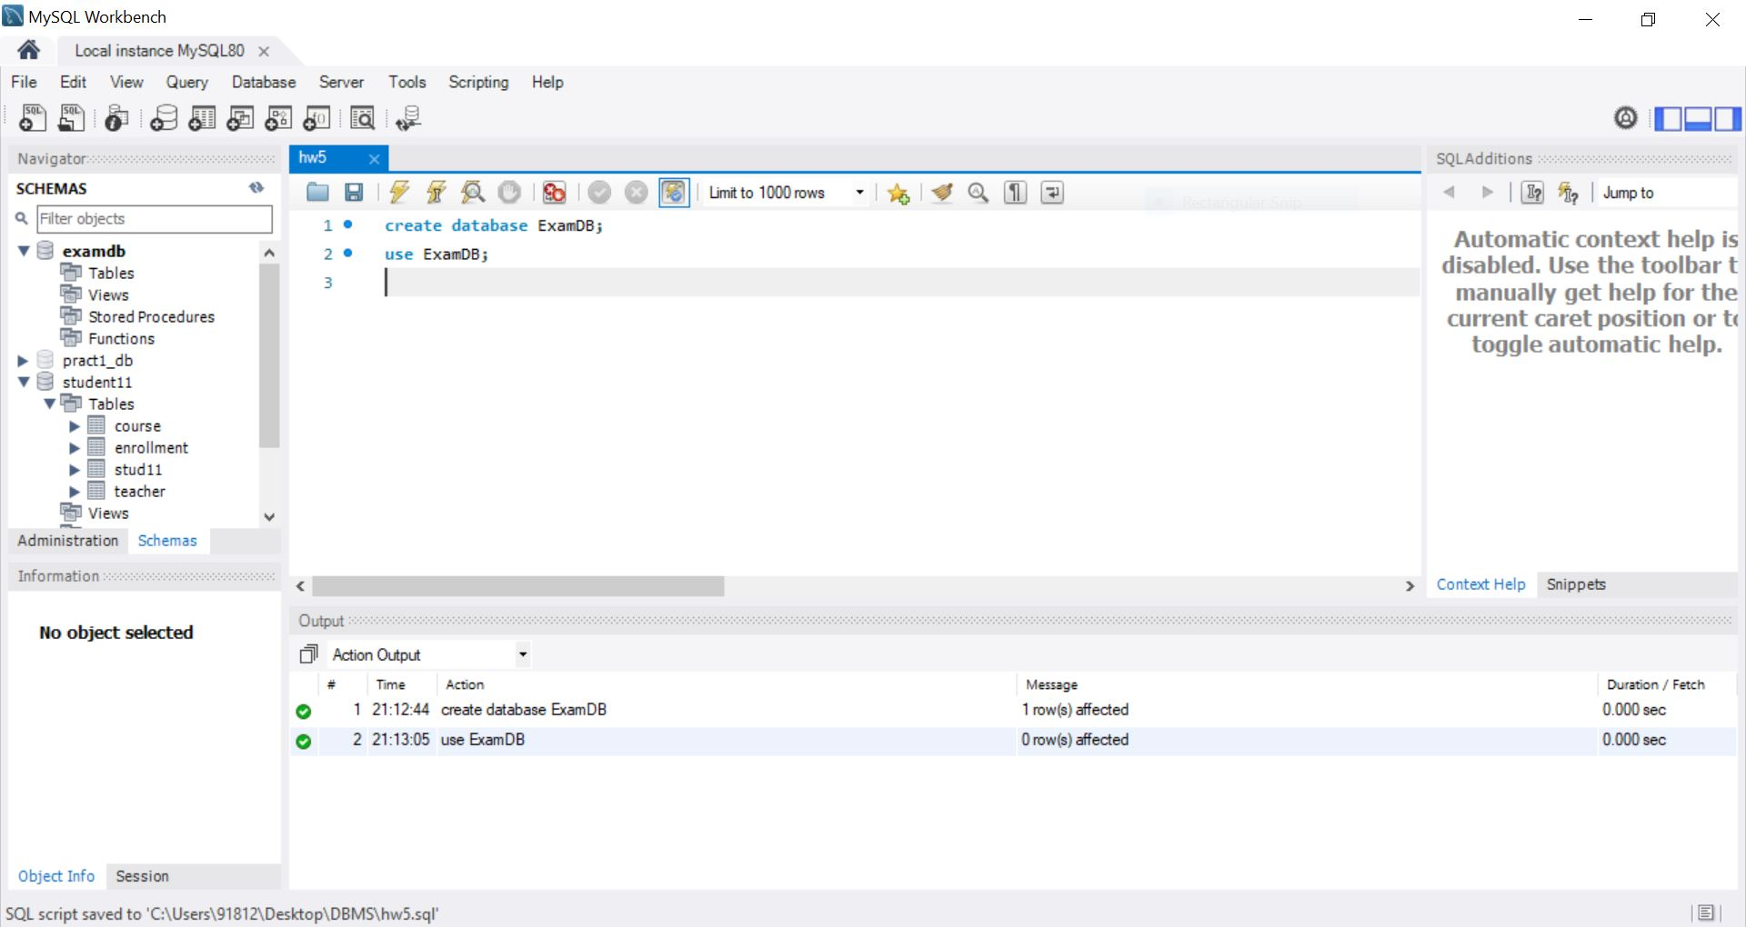
Q- In ExamDB, create a table Student with the following structure:
● StudentID (Primary Key)
● Name (Not Null)
● Email (Unique)
● Gender (ENUM: ‘Male’, ‘Female’, ‘Other’, default = ‘Other’)
● DOB (Date)
Answer: -
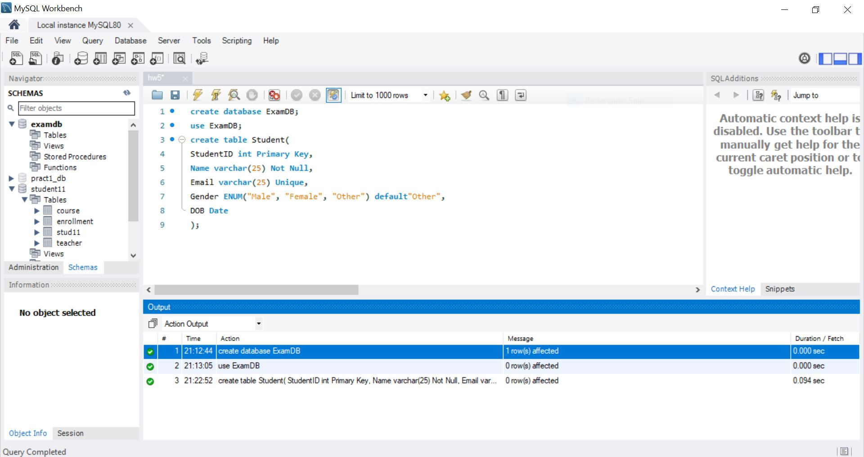
Q- Insert at least 3 records into the Student table.
◦ Gender for one student to test the default value.
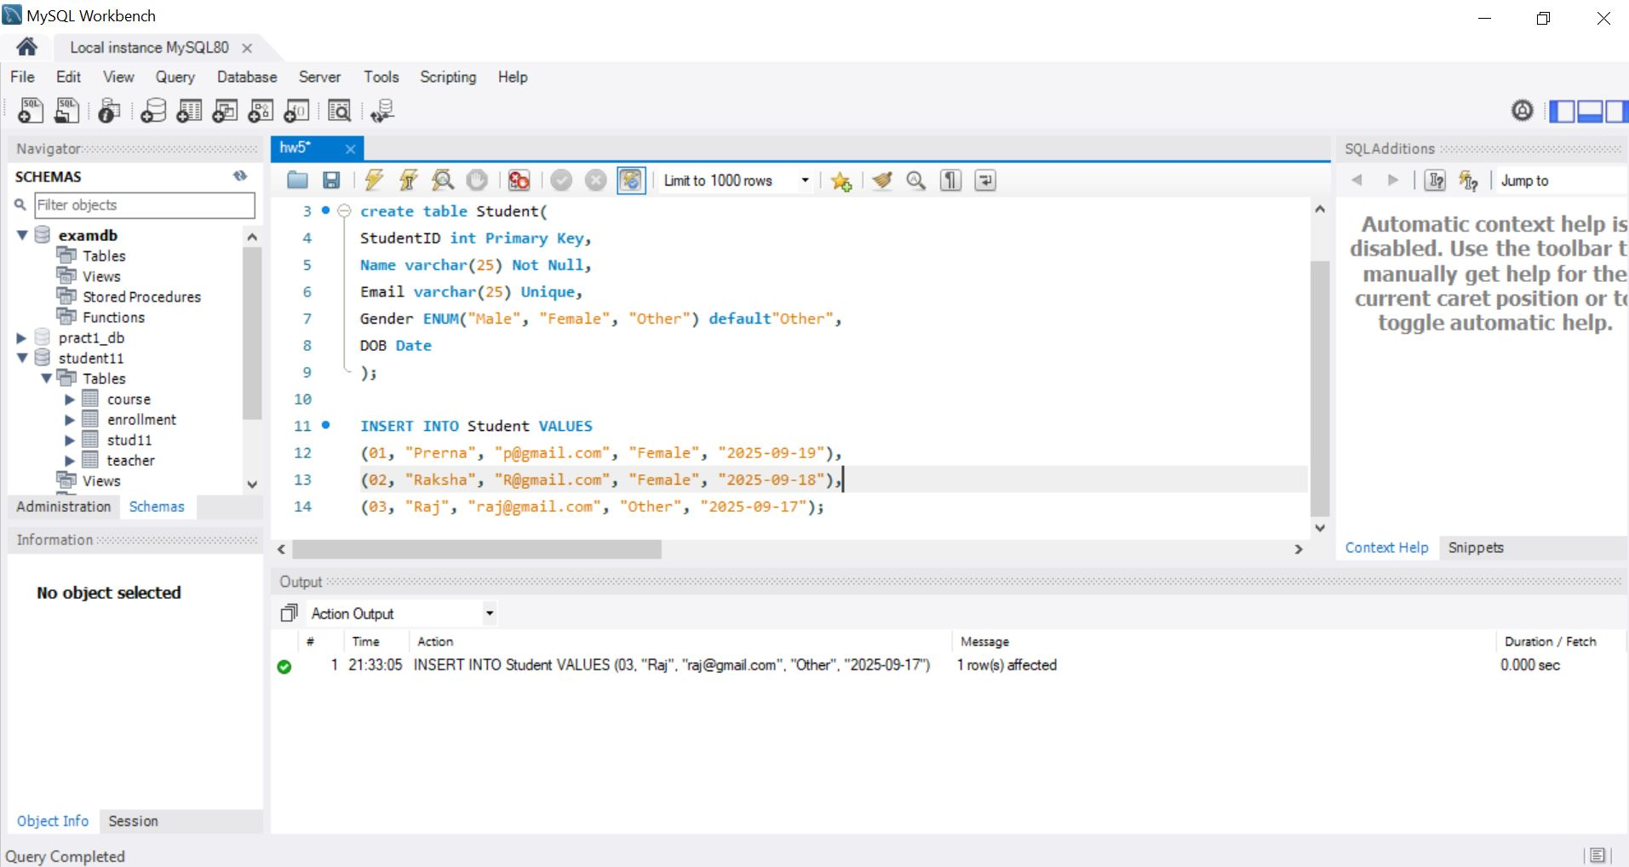

Q- Try inserting a record into Student with a duplicate Email and note the error.
Answer: -
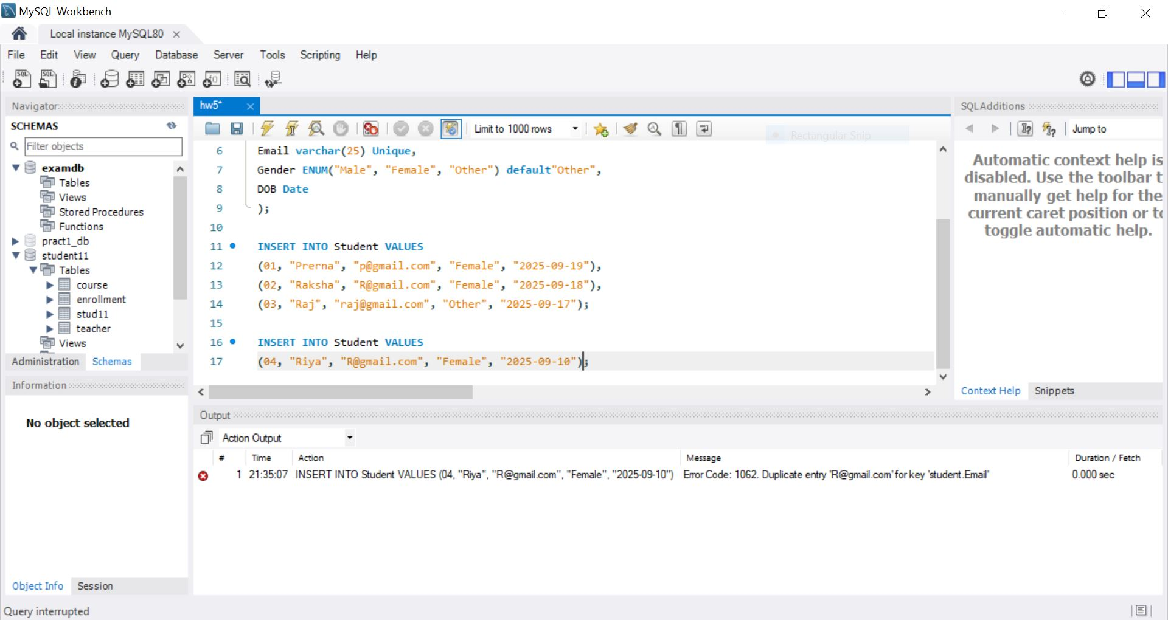

Q- Create a table Course with the following columns:
- CourseID (Primary Key), Title, Duration.
-Insert at least 3 records into Course.
Answer: -
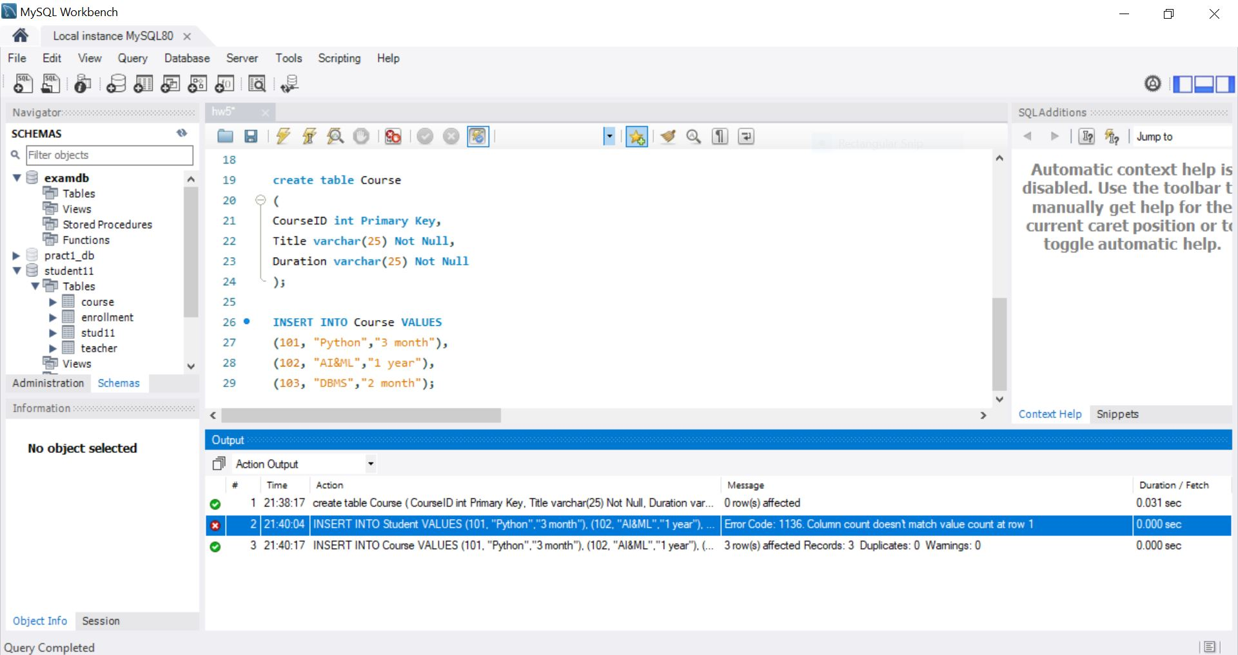

Q- Create a table Enrollment with the following columns:
- EnrollmentID (Primary Key), StudentID , CourseID , EnrollDate (Default current date/time).
-Insert at least 2 records.
Answer:-

